**GharBeti**

Submitted in partial fulfillment of the requirement of

**Project – IV** (**BEG**)

Of

Bachelor of Computer Engineering



**Submitted to**

Purbanchal University

Biratnagar, Nepal

Submitted By:

Bikash Gupta()

Laxmi Gajurel ()

Pratik Subedi()

**KANTIPUR CITY COLLEGE**

Putalisadak, Kathmandu

August 10, 2022

A Project Reports

On

**GharBeti**

Submitted in partial fulfillment of the requirement

Of

**Project–IV (BEG)**

Of

****Bachelor of Computer Engineering

**Submitted to**

Purbanchal University

Biratnagar, Nepal

**Submitted By:**

Bikash Gupta()

Laxmi Gajurel (382218)

Pratik Subedi ()

**KANTIPUR CITY COLLEGE**

Putalisadak, Kathmandu

March 4, 2022

# TOPIC APPROVAL SHEET

It is hereby informed that the topic selected by Bikash Gupta, Laxmi Gajurel and Pratik Subedi of Bachelor of computer engineering, Semester VIII for their semester project has been found suitable and as per the credit assigned by Purbanchal University (PU), Biratnagar, Nepal.

The project committee has approved the following topic for the above mention students.

**Topic Assigned: GharBeti**

## ___________ ___________ ___________

Bikash Neupane Raju Kuttel Merry Singh

Project Coordinate Principal Supervisor

# CERTIFICATE FROM SUPERVISOR

The Evaluation Committee has approved and recommended to the Department of Science and Technology for acceptance of this project report entitled “Sales & Inventory Management System” submitted by:

Bikash Gupta(symbol No:)

Laxmi Gajurel (Symbol No.: 382218)

Pratik Subedi (Symbol :)

Evaluation Committee

Mrs. Merry Singh

Supervisor,

Kantipur City College

(---------------------------------------)

External Examiner

Mr. Raju Kattel

Head of the Department of IT

Kantipur City College

Date: 2078/11/20

**ACKNOWLEDGEMENT**

We would like to express our sincere gratitude and thanks to Kantipur City College and Deputy Head of the department Mr. Subash Rajkarnikar for providing us this opportunity to perform our project.

And, our extreme gratitude goes to our supervisor Mrs. Merry Singh who guided us throughout the project. She has contributed her precious time and energy to complete our project. Without her willing, accommodation, frankness, suggestions and timely clarification, this project could not have been completed in due time.

We would like to thank all other individuals who have contributed directly or indirectly to the success of this project.

# ABSTRACT

Our Project is about “GharBeti” aimed at developing a website of “Rental System Management System” for finding a place to rent. This system can be used to find the details of the rental place, update the rental detail, produce record of tenant payment and add, edit and remove the tenant and landlord detail etc. This is one integrated system that contains both the user component (used by landlord, and tenant) and the admin component (used by the administrators for performing admin level functions such as adding new landlord to the System). This system runs on multiple terminals, offers a GUI interface to its users and connects to a common database. It can be use in any operating system like Linux, Window and Mac etc.

# ABBREVIATIONS

KCC: Kantipur City Collage

PU: Purbanchal University

DFD: Data flow diagram

SQL: Structured Query language

UI: User Interface

UX: User Experience

# Chapter 1: Introduction

## Introduction

As we, all know it is difficult to manage time for daily needs in this fast-moving world. With this case there is a need for change in a technological field, there's an urgent must embrace and appreciate the power of innovative technology. So there is a vital situation to manage one in all the essential need that's a shelter or home for survival. If we are not known to an individual in some cities and want to rent a house, room, apartment as well as shop then it's difficult to hunt out suitable aim time. Hence, there's a requirement to develop a “Gharbeti” App that will simplify the work for the rental managers and tenants so all their works are often done efficiently and effectively. It's also difficult to hunt out the renter on time, for the owner and property managers. This App will provide the whole knowledge about houses and apartment which is accessible for Rent. It will make easy to hunt out the position of Houses, need of rooms and other facts by the renter. Using this app the Landlords even have provision to post or update their property details whenever they want.

* GharBeti App is fully static and effective app. It'll provide the knowledge to the tenants about the homes which are accessible for Rent. They can easily search for their needs using keywords like property type, location, etc.
* On the other side, the Landlord has the facility to post or modify their property details with admin approval.
* It can be helpful to easily upload the position, phone number, Expected rent, No. of rooms, Facilities and other information by the

**Modules used in this project**

This project has two major modules that are:

**Landlord:**

* Registration by the landlord: First, the owner of the house should register their land with their name, location, contact No, expected rent, No. of rooms, Facilities and other information.
* Login by Landlord: the owner uses the app by login into the app with their login credentials.
* Add Tenants: New Tenant is added by the landlord by entering Tenant personal details with verification ID.
* Update availability: Owner can moderate or update no. Of rooms, area,
* Generate the rent invoice: Monthly bill is generated for the renters.
* Payment status: View payment status and easily detects which tenant has paid, not paid and have balance.

**Tenants:**

Registration by the tenants: First, the tenant should register themselves by their names and private details like id, contact,

Login by the tenants: The Tenant uses the app by login into the app with their login credentials.

Add Requirements: Tenants can upload their requirements to appear house as per their choice.

Search houses location: they will search about feasible lands and placement in their budget.

Handling Payment: Payment details can be viewed, the status of payment, and submit

## Problem Statement

In Nepal, there does not have online rental management system for who wants to rent get a lot of trouble to find place for rent even the place is available.

There is no properly allocate place and the system is not easily arrange according to their user interest. The rental management system almost done through the manual system.

The administrative system does not have the facility to make rental Management system through online and the most time the work done through illegal intermediate person without awareness of the administrative and this make more complex and more cost to find room for the customer. This leads customer to face more trouble, cost, dishonest and time wastage. The problem found in the current system:

* Complexity of finding home is not easy and more tedious.
* Need Extra money to find home.
* The system needs power that is more human.
* The user cannot get information about home when they need.
* There is too match time consumption find home.
* Complexity of the system for payment.
* An emergency repair is required when something in the rental unit has broken and the health or safety of the tenant is in danger or the building or property is at risk until repairs can made.

Management has become difficult because of issues that include:

**i. Data growth:**

Data increase day to day. Storing and maintaining all data manually is very difficult.

**ii. Lack of computerized system**

Currently most landlords/property managers use the manual system in recording and maintaining their property and customers data

**iii. Data security is not assure**

In a manual way, data is record on books/papers, which may easily be damage leading to loss of data.

**iv. There is no database to store information**

Potential of data loss or damage is very high because data is stored on tangible files. Lack of these crucial requirements makes management of the tenants and houses very difficult as some tenants may end up not paying rent.

## Objectives

* To facilitate tenants record keeping for who wants room and for administrative management system.
* To prepare an online rental system for the room, apartment and shop finders.
* To make tenants and landlord easy to know the record.

## Significance of project

* It helps the owner to find the tenants easily.
* This app verify both owner and the tenants before they contacts each other by using the document, which verify them as a real person.
* It helps the tenants to find the room easily without searching from one home to another.
* It provide the actual location of the rental house.
* The tenant and owner easily able to update modify and delete their detail and no. of room and house.
* We are able to contact the owner without the agent.

## Project Feature

Some of the useful and important features of “GharBeti” are-

* Admin, landlord and user has log into the system.
* Landlord and user have to register before login into the system.
* It has ability to add & remove different rental detail
* Admin panel
* Landlord add , update and remove personal as well as rent detail
* Tenant edit & add the rent.
* Admin is able to manage landlord and tenant.
* Type of room/rental place show with their price.
* Admin and landlord can view the report

## Assignment of role and responsibility

We assigned the roles and responsibilities equally among all members of the group. There are various phases during the project such as analysis, coding, testing, debugging, documentation etc. The coding phase itself involves frontend and backend development as well as data entry. As team members, we shared all the work and regularly communicated and helped each other for the successful completion of the project.

## Project Documentation

Documentation is an important part of any software project. It informs both software developers and users. The documentation for our project was develop throughout the life cycle of the project. The documentations have been separate into different steps.

# Chapter 2: Literature Survey

## 2.1. Literature Review

Literature review is a text written by someone to consider the critical points of current knowledge including substantive findings as well as theoretical and methodological contributions to a particular topic. Main goals are to situate the current study within the body of literature and to provide context for the particular reader

**DalayDai.Com**

**99ACRES**  
Created by the popular property search portal 99acres.com, this app offers the same user experience as the website, on the go. The app, which is free for Android users, allows you to browse properties for rent, along with high quality pictures, videos and maps. It is best known for the numerous options it provides, with listings of around 10 lakh properties across the country. It also promises instant contact between landlords and interested tenants through phone calls, text or email.

**NOBROKER**  
This app stands for what everyone looking to rent wants to do: cut the broker out of the equation. It lets us find and rent a house without paying any brokerage. Most of us feel that having to pay a hefty brokerage fee is unfair. The No-Broker app resolves this by letting home owners list their properties easily and then putting them in touch with potential tenants. We can contact the homeowner directly through the app after shortlisting a property.

**FLATCHAT**  
This app provides a platform where homeowners and potential tenants can share their location, find contacts in their vicinity and chat with them. It also allows you to sign up to find suitable flat mates to share a rental with. This can make the otherwise difficult process hassle free, since you can find people with the same budget and location preference as you, as well similar hobbies and habits. So far, the app is only functional in Bengaluru, Mumbai, Pune, and Delhi.

**NESTAWAY**  
This app’s appeal lies in the fact that it offers many fully furnished rental options with standardized amenities, and Nest Away takes responsibility for making sure that these are in working order. Once we shortlist a property, we can schedule a visit through the app, saving the trouble of calling and coordinating with owner or agent. The app stores important documents like rental agreements and receipts for easy access. It also allows us to book prefer.

## 2.2. Existing System

At present, the people of our country suffer a lot for want of accommodation

according to their demand. They've to run to and fro for their desired house to

buy/rent. They have to go through every corner of society to get information about the

house/land that is available. Similarly, a landlord/house owner also has to suffer

sometime when he wants to rent/sell his properties. He has to expose the subject

people to people to get his desired client. To solve these types of problems, we're

going to introduce HOUSE RENTAL system.

At present, the people of our country suffer a lot for want of accommodation

according to their demand. They've to run to and fro for their desired house to

buy/rent. They have to go through every corner of society to get information about the

house/land that is available. Similarly, a landlord/house owner also has to suffer

sometime when he wants to rent/sell his properties. He has to expose the subject

people to people to get his desired client. To solve these types of problems, we're

going to introduce HOUSE RENTAL system.

At present, the people of our country suffer a lot for want of accommodation

according to their demand. They've to run to and fro for their desired house to

buy/rent. They have to go through every corner of society to get information about the

house/land that is available. Similarly, a landlord/house owner also has to suffer

sometime when he wants to rent/sell his properties. He has to expose the subject

people to people to get his desired client. To solve these types of problems, we're

going to introduce HOUSE RENTAL system

At present, the people of our country suffer a lot for want of accommodation

according to their demand. They've to run to and fro for their desired house to

buy/rent. They have to go through every corner of society to get information about the

house/land that is available. Similarly, a landlord/house owner also has to suffer

sometime when he wants to rent/sell his properties. He has to expose the subject

people to people to get his desired client. To solve these types of problems, we're

going to introduce HOUSE RENTAL system

At present, the people of our country suffer a lot for want of accommodation

according to their demand. They've to run to and fro for their desired house to

buy/rent. They have to go through every corner of society to get information about the

house/land that is available. Similarly, a landlord/house owner also has to suffer

sometime when he wants to rent/sell his properties. He has to expose the subject

people to people to get his desired client. To solve these types of problems, we're

going to introduce HOUSE RENTAL system

At present, the people of our country suffer a lot from rental place of accommodation according to their demand. They have to run back and forth for their desired house/room/flat/apartment to rent. They have to go through every corner of society to get information about the house/room/flat/apartment that is available. Similarly, a landlord/house owner also suffer when he/she wants to rent their properties. They have to expose the subject people to get desired client. To solve these types of problems, we introduced Gharbeti application.

## 2.3. Analysis of issue

. The problem found in the current system:

* Complexity of finding home is not easy and more tedious.
* Need Extra money to find home.
* The system needs power that is more human.
* The user cannot get information about home when they need.
* There is too match time consumption find home.
* Complexity of the system for payment.
* An emergency repair is required when something in the rental unit has broken and the health or safety of the tenant is in danger or the building or property is at risk until repairs the system.

Management has become difficult because of issues that include:

**i. Data growth:**

Data increase day to day. Storing and maintaining all data manually is very difficult.

**ii. Lack of computerized system**

Currently most landlords/property managers use the manual system in recording and maintaining their property and customers data

**iii. Data security is not assure**

In a manual way, data is record on books/papers, which may easily be damage leading to loss of data.

**iv. There is no database to store information**

Potential of data loss or damage is very high because data is stored on tangible files. Lack of these crucial requirements makes management of the tenants and houses very difficult as some tenants may end up not paying rent.

## 2.4. Solution

# Chapter 3: System Analysis

## 3.1. System Development model

System development methodology is a technique that is used to show how the propose system will be developed. In this case, the methodology used will be a waterfall model.

**Waterfall Model**

It is comprised of the stages that the developer will use when developing the systems. It is sequential model hence the name is waterfall. The developer has to finish with one stages before going to the next one. It comprises of the feasibility study, analysis phase, design phase, coding phase, testing phase, implementation phase and finally maintenance phase. It is a simple and easy model to use and understand. With waterfall development based methodologies, the analysts and users proceed sequentially from one phase to the next. The deliverables from each phase are voluminous and are present to the project sponsor for approval as the project moves from phase to phase. Once the sponsor approves the phase, it ends and the next phase begins.

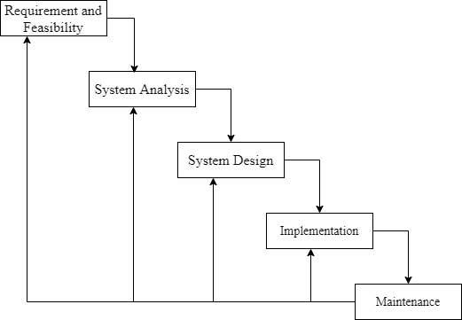

## 3.2. Requirement Specification

Requirement specification involved defining consumer needs and objectives in the context of planned consumer use environments and identified system characteristics to determined requirements for system functions.

### 3.2.1. Functional Requirement

This is a necessary task, action or activity that was accomplish. The proposed system is able to:

1. Allow admin to add a houses, tenant and defaulters details.
2. Allow the user to delete houses, tenants and defaulters details.
3. Allow the admin to search data in the database.
4. Allow admin to edit data in the database.

|  |  |
| --- | --- |
| **Actor** | **Function** |
| Landlord | * Advertise the house * Adding information about the house. |
| Tenant | * Search the house * Select the house they wants * Register to rent the house |
| Admin | * Edit data in the database * Delete data in the database * Update data in the database * Delete tenant and landlord. |

**Performance Requirements**

The system should respond within a short period. It depends on the performance of the hardware environment such as RAM and processor.

**Process Requirements**

The system should documented expectations, targets and specifications for business processes. They may be collected from multiple groups of stakeholders such as business units, customers, internal customers, users and subject matter experts.

**Input Related Requirements**

The system should set all input bundles required to produce at least a given level of outputs.

**Output related Requirements**

The system should be predominantly adopts performance-based required to define the project scope.

**Storage related Requirements**

The system should include any necessary periodic preservation or condition checks.

### 3.2.2. Non Functional Requirement

The official definition for a non-functional requirement specifies how the system should behave: “A non-functional requirement is a statement of how a system must behave; it is a constraint upon the system behavior.” Non-functional requirements specify all the remaining requirements not covered by the functional requirements. They specify criteria that judge the operation of a system, rather than specific behaviors.

### Hardware Interfaces

Hardware interfaces between all systems regardless of any pre-existing network that supports TCP/IP

### Software Interface

The software interfaces between all systems will be implement on all operating system at which it is compatible with software frameworks:

### Other Non-Functional Requirements

1. **Security Requirements**

Privacy and security requirements: are concerned with keeping the information private and confidential. The online Trade Interaction needs to provide for the communication sessions conducted between two parties or more the complete and ultimate privacy, away from the interference of outsides. The data and information exchange between any two peers or more in the online Trade Interaction are consider highly private and some of the information is inaccessible, even for the Retailor, to look at them. Moreover, the system should only permit the parties or peers that their usernames and passwords match the ones saves in the database from logging into the system. Unauthorized peers cannot log in or access the system, as this step is called the authentication.

### Software Quality Attribute

### The system shall be intuitively usable.

Input fields shall be clearly labeled with terms meaningful to a tenant, landlord and admin.

Buttons shall be clearly labelled with terms meaningful to the tenant, landlord and admin.

1. **Business Rules(Security Issues)**

* Any of system users shall never log in to another system user. This secured for each system interface from accessing authorized users through authorized the database table only for those user who have a special privilege.

### Hardware Requirements

1. Processor
2. Memory
3. Visual Display Unit

### Software Requirements

1. Operating System- window, Mac, etc.
2. Microsoft Office PowerPoint- Used during Presentation
3. Microsoft office- Used during documentation
4. Visual Studio- Used during coding and edit code.

## Feasibility Study

The feasibility study is the preliminary study that determines whether a proposed system project is financially, technically and operationally. Feasibility study is essential to evaluate the cost and benefits of the new system. The alternative analysis usually include as part of the feasibility study, identifies viable alternatives for the system design and development.

### Operational Feasibility

The system to be developed will provide accurate, active, secured service and decreases labor of workers and it is not limited to particular groups or body. The system will easily operational, as it does not affect the existing organizational structure and support the current system. Therefore, the system will be operationally feasible.

### Technical Feasibility

The system to be develop by using technologically system development technical such as JavaScript, Flutter and database without any problems and the group members have enough capability to develop the project. Our focus is to develop well-organized dynamic web site that is technically effective for managing the Online Trade interaction system. Therefore, it can be concluding that the system is technically feasible.

### Economic Feasibility

The system to be develop is economically feasible and the benefit is outweighing the cost. Since this project already computerizes, the existing system and more advanced than the current system and more advance than the current system reduces and change the labor force to computerize system. Reduces the cost of the cost of the material used.

### Legal and Contractual Feasibility

The system is free from any legal and contractual risks

### Scheduled Feasibility

The project will be complete according to a planned schedule. The planned schedule is display in the form of a Gantt chart.

|  |  |  |  |  |  |  |  |  |  |  |  |  |  |  |
| --- | --- | --- | --- | --- | --- | --- | --- | --- | --- | --- | --- | --- | --- | --- |
| S. N | Tasks | Duration (in Week)-Starts From (25th July 2020) | | | | | | | | | | | | |
| 1 | 2 | 3 | 4 | 5 | 6 | 7 | 8 | 9 | 10 | 11 | 12 | 13 |
| 1 | Concept submission |  |  |  |  |  |  |  |  |  |  |  |  |  |
| 2 | Resource collection |  |  |  |  |  |  |  |  |  |  |  |  |  |
| 3 | Research and analysis |  |  |  |  |  |  |  |  |  |  |  |  |  |
| 4 | System Design |  |  |  |  |  |  |  |  |  |  |  |  |  |
| 5 | Coding |  |  |  |  |  |  |  |  |  |  |  |  |  |
| 6 | Testing and debugging |  |  |  |  |  |  |  |  |  |  |  |  |  |
| 7 | Documentation |  |  |  |  |  |  |  |  |  |  |  |  |  |

# Chapter 4: Design Specification and Implementation

## 4.1. System Architecture

A system architecture is the conceptual model that defines the structure, behavior and more views of a system. It is the structure of an IT system. The system architecture is based of the Dart and flutter architecture.

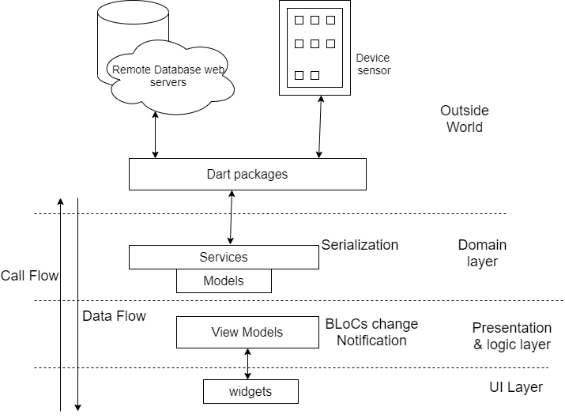

## 4.2. Data Flow Diagram (DFD)

A data flow diagram (DFD) is a graphical representation of the "flow" of data through an information system, modeling the aspects of the operation. They are also a preliminary step used to build an outline of the system that can be built later. DFDs can also be used to simulate data processing (structured design) for the visualization of data processing. A DFD illustrates what sort of information is input to and output from.

### 4.2.1. Context Diagram

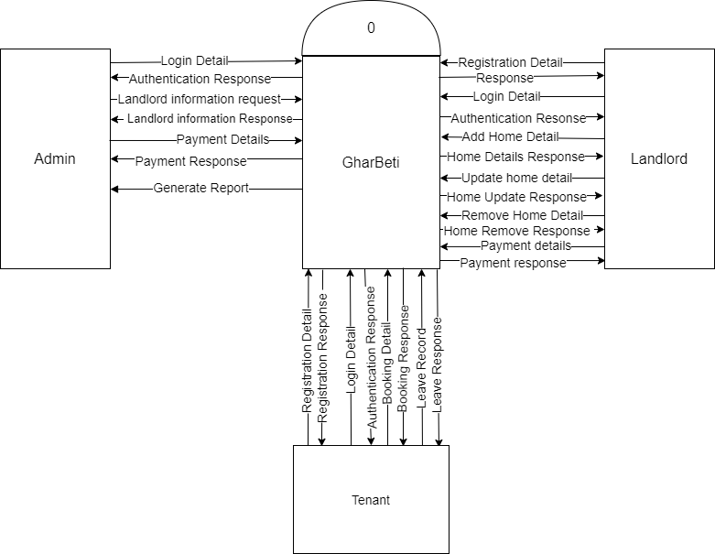

### 4.2.2. DFD Level 1

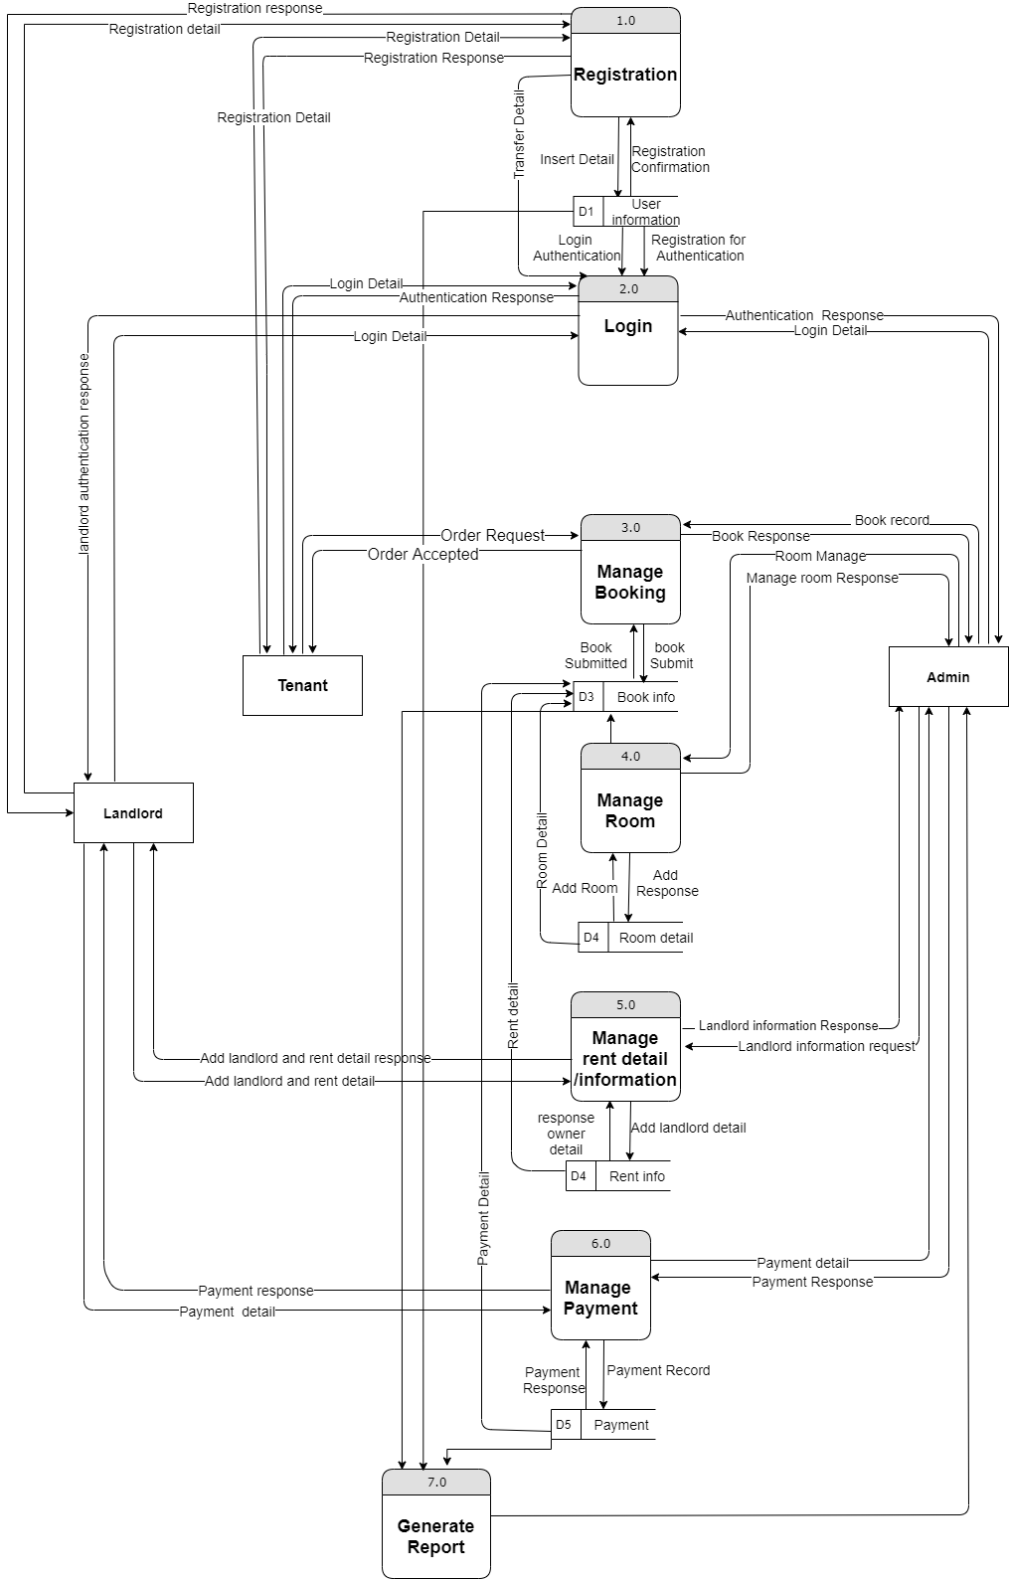

## 4.3. Use Case Diagram

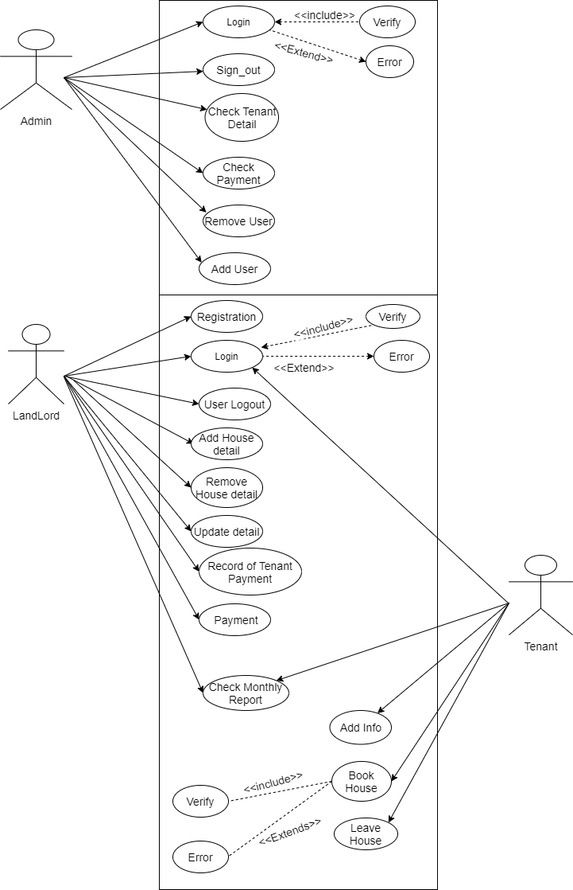

## Activity diagram

It shows the control flow from one activities to another. Activity diagram is another important diagram to describe dynamic behavior. Activity diagram consists of activities, links, relationships etc. It models all types of flows like parallel, single, concurrent etc. Activity diagram describes the flow control from one activity to another without any messages. These diagrams are used to model high-level view of business requirement.

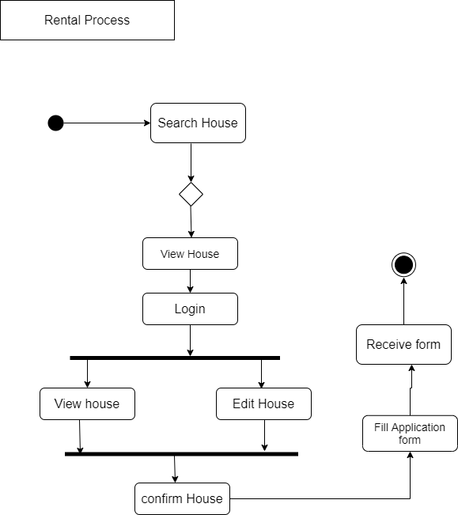

## Database Diagram

The database stores most of the information required by the system. The database will be a MySQL backend, which is a relational database management system (DBMS) that is based upon the Structured Query Language (SQL).

### 4.5.1. E-R Diagram

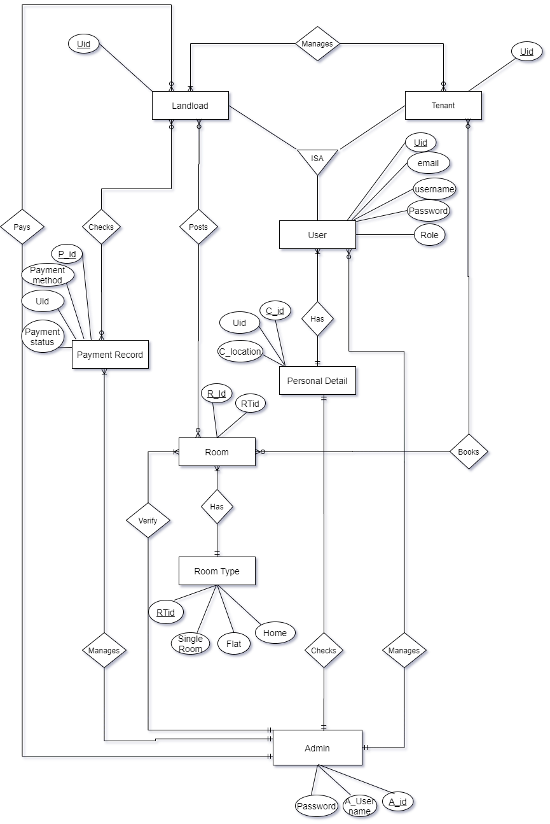

### 4.5.2. Relational Data Structure

### 4.5.3. Data Dictionary

The data dictionary is useful in case of development.

**Table Name:** Admin

**Primary Key:** Admin ID

**Description:** To store the details of admin

|  |  |  |  |
| --- | --- | --- | --- |
| **Serial No.** | **Field** | **Datatype** | **Description** |
| 1. | Admin ID | Integer | Primary Key |
| 2. | Name | Varchar |  |
| 3. | Email ID | Varchar |  |
| 4. | Contact No. | Integer | Multiple contacts can exist for a single admin |
| 5. | Address | Varchar |  |

**Table Name:** User Master

**Primary Key:** User ID

**Description:** To store the detail of Users

|  |  |  |  |
| --- | --- | --- | --- |
| **Serial No.** | **Field** | **Datatype** | **Description** |
| 1. | User ID | Integer | Primary Key |
| 2. | Name | Varchar |  |
| 3. | Email ID | Varchar |  |
| 4. | Contact No. | Integer | Multiple contacts can exist for a single admin |
| 5. | Address | Varchar |  |

**Table Name:** Property Master

**Primary Key:** Property ID

**Description:** To store the detail of Property

|  |  |  |  |
| --- | --- | --- | --- |
| **Serial No.** | **Field** | **Datatype** | **Description** |
| 1. | Property ID | Integer | Primary Key |
| 2. | Owner ID | Integer | Foreign key to user master |
| 3. | Location | Varchar |  |
| 4. | Status | Varchar | Available, rented, etc. |
| 5. | Total value | Float |  |

**Table Name:** Book Master

**Primary Key:** Book ID

**Description:** To store the detail of Booking

|  |  |  |  |
| --- | --- | --- | --- |
| **Serial No.** | **Field** | **Datatype** | **Description** |
| 1. | Book ID | Integer | Primary Key |
| 2. | Property ID | Integer | Foreign key to Property Master. |
| 3. | Owner ID | Integer | Foreign key to Owner Master. |
| 5. | User ID | Integer | Foreign key to User Master. |

**Table Name:** Payment Master

**Primary Key:** Payment ID

**Description:** To store the detail of Booking

|  |  |  |  |
| --- | --- | --- | --- |
| **Serial No.** | **Field** | **Datatype** | **Description** |
| 1. | Payment ID | Integer | Primary Key |
| 2. | Book ID | Integer | Foreign key to Book Master. |
| 3. | Transaction no. | Varchar | Transaction number |

## 4.6. UI/UX Mechanism

The development is based on a web application, so the UI is in the form of a web. To view different pages on the window, Linux or Mac there will be a navigation menu that offers drop-down menus. To provide a smooth user interface, we make use of buttons, form, graphics etc.

## Chapter 5 Experimental Result and Analysis

## 5.1. Programming platform

The project is developed based on web develop techniques. Data is stored in databases. The application uses the following platforms and technologies

Strapi:

Sqlites:

Flutter

Dart

JavaScript

We also used following tools or software for development of the application.

Microsoft Word (Documentation)

Visual Studio Code (text editor)

(Running, testing and debugging)

Draw.io (Drawing & Figures)

## 5.2. Operating Environment

The “GharBeti” is internet based so it will run in any Operating System with internet access through a web browser.

* API
* Sqlite3 server

## 5.3. Testing and De bugging

### 5.3.1. Testing

Each component is tested independently, without other system components interfering. This process is concerned with finding errors. It is also concerned with validating that the system meets its functional & non-functional requirements.

|  |  |  |  |
| --- | --- | --- | --- |
| S.NO | Test Case | Expected Results | Actual Results |
| 1 | Sign in with empty admin name & password | Should display error message | Passed |
| 2 | Sign-in with invalid user name & password | Should display error message | Passed |
| 3 | Sign-in with valid user name & password | Should successfully Sign-in | Passed |
| 4 | Add a rental place with empty field | Should display error message | Passed |
| 5 | Add a rental place with Valid info | Should successfully add rental place | Passed |
| 6 | Landlord add place and personal detail with empty field | Should display error message | Passed |
| 7 | Tenant reserve rental place | Should successfully Reserved | Passed |
| 8 | Tenant reserve rental place with empty field | Should display error message | Passed |
| 9 | In report, landlord provide empty field | Should display error message | Passed |
| 10 | Fill report form by landlord | Should successfully show the report | Passed |

## 5.3. Experiment And Result Analysis

### 5.3.2. Expected Result

* Application will be a service, which will connect Renters and Landlords and vice versa.
* It will save the physical hard work and invaluable time to find room/flat/shop.
* It will save Resources for search the rooms/house/flats/shop.
* It will be an Open Source Application which can be freely Install in android smart Phones.
* Application will make easy to find rooms/flats/houses/shops for the tenants and upload the location and other information by landlord/room-master.

# Chapter 6

## 6.1. Conclusion

Online rental business has emerged with a new possibilities compared to the experience where every activity concerning rental business was limited to a physical location only. Even though the physical search for houses has not been totally eradicated; the nature of functions and how these functions are achieved has been reshaped by the power of internet. Nowadays, renters can reserve houses online once the customer is a registered member of the application. The app based house rental system has offered an advantage to both landlords as well as the tenants efficiently and effectively just with the click of a button.

## 6.2. Limitations

## 6.2. Future Enhancement

**Reference**

[**https://pdfcoffee.com/a-project-on-online-house-rental-management-pdf-free.html**](https://pdfcoffee.com/a-project-on-online-house-rental-management-pdf-free.html)

[**https://www.slideshare.net/FNISHA/apartment-management-system-project**](https://www.slideshare.net/FNISHA/apartment-management-system-project)

**Bibliography**

**Appendixes**